Organization:  LightingEurope |  | Date: 10 July 2015

Task # | Section # | Page # | Topic | Comment | Proposed change
 | Summary&conclusions | 5 | No halogen lamps were found on the market which fulfil the EEI<0.95 stage 3 criterium of Regulation 1194/2012 |  | No Mains Voltage halogen lamps were found on the market which fulfil the EEI<0.95 stage 3 criterium of Regulation 1194/2012
 | Summary&conclusions | 6 | In conclusion, this market assessment presents the evidence that there are mains-voltage lamps on the market fulfilling all the necessary conditions laid out in Regulation 1194/2012 for stage 3 to apply to mains-voltage filament lamps. | [Are these lamps compliant to EU CE requirements? Has this been tested by certified independent test houses?]
 | 2. Methodology for the market study | 11 | Dimmability | Dimmer compatibility: suppliers claiming dim ability for the LED range cannot guarantee a broad dimmer compatibility; The study takes the commercial claim for granted, but does not test this.  Many dimmable led lamps cannot dim low, start to hum or flicker when dimming.  In many cases applying a dimmable LED alternative will result in the need to replace also a new dimmer. This will increase the payback period considerably
 | 2. Methodology for the market study | 12 | Efficacy: computed for information only, as lumen divided by power. It has been assumed that declared lumen values are compliant with the definition in regulation 1194/2012 (see also point 2). Where both nominal and rated values were available for lumen and/or power, rated values have been used for efficacy computations. | [declared lumen values are assumed to be compliant. This should have been underpinned by appropriate testing]
 | 2. Methodology for the market study | 13 | The thermal effects of the substitution of a halogen lamp by a LED lamp have not been evaluated: these depend on the type of luminaire and on the burning position, which in general are unknown in this study. | [This should have been researched more carefully].
 | 2. Methodology for the market study | 15 | R39 | Form factor: For R39, R50/63/80, it is assumed too easily that consumers may compromise on shape, because most luminaires for spots are typically designed around the bulb shape (eg R50 does not fit in R39 luminaire).
 | 3. MV DLS equivalence data | 15 | R39 | different from VITO conclusion, R39 has NO LED alternative with beam angle even close, other lamp (R50) will not fit in most cases and non-dimmable. Wide availability is doubtful
 | 3. MV DLS equivalence data | 22 | R63 | R63 has no alternative for lumen packages below 400lm which is the domain of the common GLS/Halogen types.
 | 3. MV DLS equivalence data | 26 | PAR20 | PAR20 affordability doubtful (>20 euro).
 | 3. MV DLS equivalence data | 32 | PAR38 | PAR38: few LED lamps fulfil EEI <0,2; affordability highly doubtful (>40 euro versus 8!).
 | 4 MV DLS Prices | 66 | Figure 3 shows an estimate by the study team of the price ranges for mains voltage directional halogen lamps and their potential LED retrofits. Considering these price differences, depending on the intensity of use of the lamps, pay-back times of around one year are possible. | [conclusions on pay back time not underpinned. Example E14 LED of 14 Euro versus a E14 Halogen of 2 Euro can hardly be considered affordable alternatives idem 18 versus 2,5 Euro]
 | 4 MV DLS Prices | 66 | Figure 3 shows an estimate by the study team of the price ranges for mains voltage directional halogen lamps and their potential LED retrofits. Considering these price differences, depending on the intensity of use of the lamps, pay-back times of around one year are possible. | Classification of “affordability” is doubtful; where lies the boundary of “affordability” (not entailing excessive cost…) . Concept of “payback time” (+/- 1 year) is rarely understood and considered by consumers.  Example page 66: GU10 halogen 0,6-5, but median likely below 2 euro. LED between 1,8 and 10, median likely above 5 euro, for dimmable likely >7 euro. 2 vs 7 is huge difference in view of consumers!  The preparartory study Lot8/9/19 tasks 6 explicitly mentions a payback time of 2 years for these kind of lamps

Organization:  LightingEurope |  | Date: July 2015

Task # | Section # | Page # | Topic | Comment | Proposed change
4 | Executive summary  2.10.4 | 13, 63, | LED retrofit lamp efficacy | A clear distinction should be made between professional and consumer applications:  In 2016-2020, there will be a mass-adoption of LED lamps in househols.  Lifetime of LED lamps is currently rated between 15-20Khrs. At a usage of 1000 hrs/year, these lamps will last for 15-20 years. After the peak introduction/conversion period, overall volume/needs on a yearly base will drop drastically,.  By that time one will see a move towards smarter lamps with added features:  Differentiation and drive for new replacement.  Improvement in driver and optical efficiency will be limited due to these new features  Consumer less interested in saving an additional 1-2 watts per lamp  DOE projected LED improvement roadmap, as best in class, aims at achieving 247 lm/W ultimately and at best 230 lm/W in 2020. These assumptions are made based on numerous improvements/innovation – still to happen – and will certainly come at high cost.  DOE numbers are reaching the physical limits. Industry might not focus on 95% quantum efficiency, but on further cost down by reducing the complexity of epitaxial layer and chip design  DOE show breakdown of LED efficiency, ambitious numbers, especially extraction efficiency of chip (90%, for most chip architectures expects max 86%) and package efficiency (99%, for low cost package architectures expects max 96%, in practice 92%).  Yellow phosphor quantum efficiency is approaching 98%, most gain is expected in use of so-called narrow band red phosphor (reduced waist of energy in long wavelength tail with limited eye sensitivity) and on the longer term quantum dot phosphors.  Performance at Tj = 25C (junction temperature of the LED). In practice LEDs are used in consumer applications at hot conditions, Tj=115C will move to 130C in coming years (saving heatsink costs). Penalty 12-16% in Lm/W.  General considerations on system level:  Thermal: hot / cold factor: 22% (2015) to 25% (2030)  bigger losses due to further over-drive of improved LEDs (for some lumen decay during life)  Driver efficacy:15% (2015) to 10% (2030)  best case scenario for driver incorporated in lamp  most likely will not improve due to added features (smarter, connected, etc.)  Optical efficacy:10% (2015) to 5% (2030)  assumption clear bulbs  most likely will not improve due to added features for ambiance creation  From LED to Lamp, system correction factor  61% (2015) to 64% (2030)  Note: VHK/VITO assumptions on (no) losses by 2030 are unlikely! | A clear distinction should be made between professional and consumer applications. Following predictons should be used:  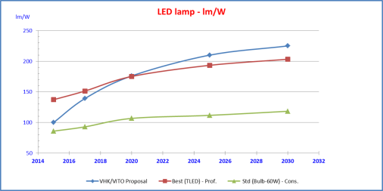  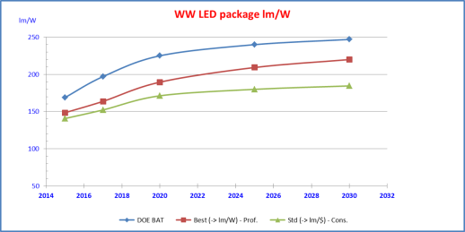

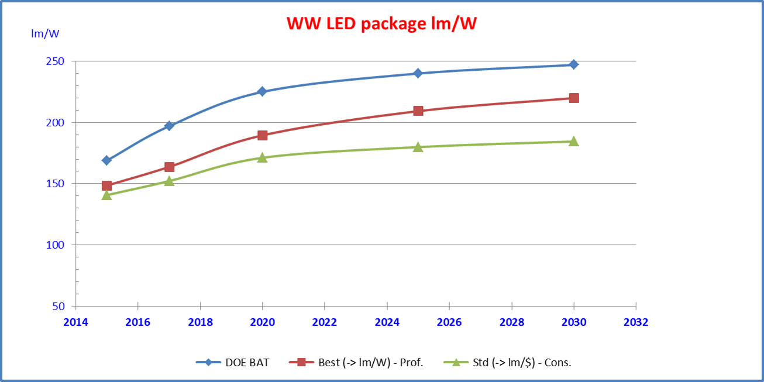

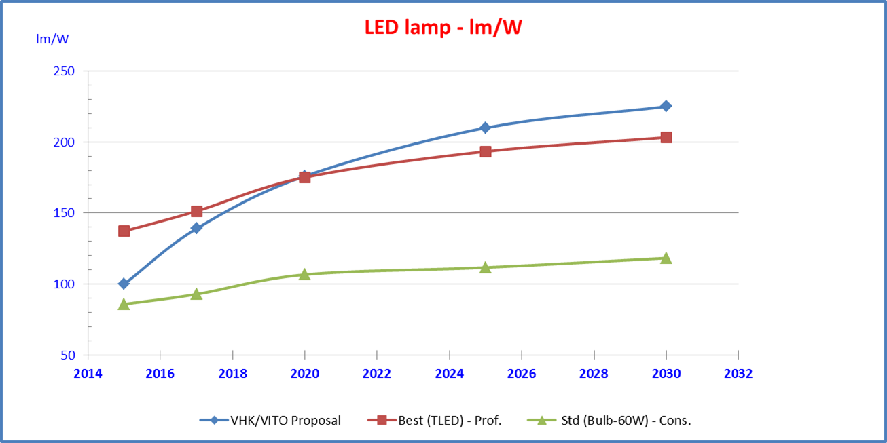

Task # | Section # | Page # | Topic | Comment | Proposed change
4 | Intro | 21 | Collection | CFL, LFL, HID 30% is collected of which 80% is recycled >> is that correct? Used in Exemptions: 2013 45,7%...
4 | 2.10.3 | 63 | LED retrofit lamp efficacy | Figure 20: only 2014 used as ‘reality point’ | Use also 2010 & 2012 realized data to make a realized trend-line
4 | 5.7.1 | 101 | CFLi base case Table 27 | Reference year 2013 used, is this still valid > 9,5W is not average (too low) | More towards 12W & efficacy of 60 lm/W
4 | 5.13.3 | 124 | BAT characteristic for LED retrofit for non-directional mains voltage halogen | Efficacy filament lamps 90 – 120lm/W & non-dim, Other LED lamps 58 – 104lm/W & come dim >> why conclusion for BAT on 1101120lm/W & DIM!!! | Lower efficacy & non-dim as BAT!
4 | 6.3 | 159 / 170 / 182 | Weight of packaging CFLi / MV HAL E / LED Retrofit | Cardboard paper cfli & halo = 54 gr, LED = 36 gr > why this difference? Plastics same 6 <> 4 gr | Packaging LED same or heavier than CFL / HALO + far more plastics used!!
5 | 3.2 | 29 | Table 14 Life cycle impact per product … over lifetime. | Weight of ‘Misc’ very high for cfli, HL MV E, HL MV X and low for LED > what is in here?  Recycling part of LED is very, very high > coming to 0 for ‘Stock’ while for CFLi and HL MV a lot remains in ‘stock’ | Explain what is in ‘Misc’ and how the shares of recycling and stock are allocated > this feels like allocating to a purpose…
6 | General / 3.9 | 44 | Table 9 Summary of design options for MV NDLS >> use life (hours) | CFLi = 6000 (many 10khrs!) and LED 2015 20K (often now going to 15K) and in 2020 still 20K (lower? 6 – 10 – 15k?) >> also included in installation costs (CFLi 3x vs LED 1x > with 10K hrs lamps just 2x!! and in future equal? | In the projection of future capabilities of LED is taken into account that besides a higher lm/W a LOWER lifetime is very likely (going down towards 6000hrs) in the race to low price points?
6 |  |  | Same table 9>> recycling | EIL recycling of LED higher than CFLi in 2015 >> based on which data?  Total weight of CFLi 119 vs LED 2015 106 >> why is CFLi more heavy?
6 | 3.10 | 48 | Table 10 Summary of design options for MV DLS lamps | Useful life (hours) HL MV X 1500 hrs >> is this correct? (not more towards 2000 / 3000 hrs)
6 | Executive Summary / 3.9 | 6, 42/43 | Payback time GLS X, Hal MV E, CFLi | Very long payback times, even for GLS and certainly for CFLi!!!
4 | Executive summary | 13 | Figure 1 | DOE 2014 efficacy curves are supposed to show lamp effy (system) but rather seems to be reflect the LED at optimal T(j). The DOE luminaire should outperform lamps (better heat dissipation)
4 | 5.9.2. | 106 | Sub 1 | The impact of replacing class C by class B halogen “will be neglected”: this is not justified, pending the proof that LED 12V spots are adequate replacement, see next comment
4 | Par 5.9.3. | 107 | Halogen LV refl | It is too easily assumed that LED alternatives are compatible to existing halogen transformers and dimmers. Tests reveal several deficiencies
4 | 5.10.3 | 111 | LV Capsules, table 33 | Dimming is missing as a key feature; LV halogen in decorative luminaires are often dimmed
4 | 5.10.3 | 111 | LV Capsules, table 33 | same comments apply as for LED LV spots on gear compatibility issues
4 | 5.10.3 | 110 | LV capsules | The potential fit issue for LED alternatives is underrated for example in common, flat under-cabinet spots
4 | 5.11.3 | 113 | MV capsules | Same comment as previous
4 | 5.11.3 | 113 | MV capsules, table 35 | Dimming is missing as a key feature; MV G9 halogen are often dimmed
4 | 5.12.3 | 117 | MV capsules, table 37 | Dimming is missing as a key feature; MV G9 halogen are often dimmed
4 | 5.13.3 | 125 | MV E, table 39 | “Declared dimmability” should not be taken for granted, as reality often reveals compatibility issues with installed dimmers

Task # | Section # | Page # | Topic | Comment | Proposed change
4 | Summary | 12 | the lm/W projections proposed  by the study team for discussion as in Figure 1. | The starting point (with margins) is up to date. Yet the future projections use the most optimistic forecast on efficacy improvement and without margin , where in the same document it is also mentioned (page 14) that the increase may freeze in near future due to market developments | Use a more realistic scenario for future improvements and a margin  on the forecast | http://www.eia.gov/todayinenergy/detail.cfm?id=15471#
4 | Summary | 16 | Re-wiring for LED tubes | The re-wiring that can be necessary for LED tubes in retrofit application is not limited to LED tubes only but applies to other categories too. | Make the observation also for other retrofit applications.
4 | Summary | 18 | Availability of retrofit for R7 | It is correctly stated that not for all R7 lamps adequate retrofit exist (due to dimensions, spatial light distribution,…)  This is also valid for other products, even for non-directional GLS and CFLi | Add references for retrofit issues for other product categories. | See figure 4 http://apps1.eere.energy.gov/buildings/publications/pdfs/ssl/led_general-service-lamps.pdf
4 | Table 17, 18, 19, etc | 80, etc | Different electricity rates used per technology | Is it a sound ecodesign criterion to use different electricity rate to compare technologies? | Use a uniform electricity rate
4 | Table 27 | 101 | 9.5 W for CFLi | Is this the ‘average’ wattage for CFLi? | Use more realistic wattage and thus efficiency; with upward trend as LED replacement starts at lower wattages (see also last paragraph on page 100)
5 | General |  | Only one LED category | Why is there only one general LED category while the other categories are split up? | Split LED into subcategories, make comparisons for same Tc, luminous equivalence as per 244/2009
5 | General |  | Product characteristics | Are figures based on actual measurements or catalogue data
5 | Summary | 6 | Figure 1 LCC | Results differ significantly from other studies | Calibrate | http://apps1.eere.energy.gov/buildings/publications/pdfs/ssl/led_general-service-lamps.pdf
5 | Table 10 | 23 | 9.5 W for CFLi | Is this the ‘average’ wattage for CFLi? | Use more realistic wattage and thus efficiency; with upward trend as LED replacement starts at lower wattages
5 | Footnote 17, table 20 | 12, 40 | Different electricity rates used per technology | Is it a sound ecodesign criterion to use different electricity rate to compare technologies? | Use a uniform electricity rate
5 |  |  | lm/W value for CFL | Typical figure of 55 lm/W for 6000 hrs is conservative for CFL. | Calibrate. Propose 12Watt average with 60 lm/w efficacy | http://apps1.eere.energy.gov/buildings/publications/pdfs/ssl/energysavingsforecast14.pdf
5 | Table 20 | 40 | Typical lm/W value per technology | 244/2009 differentiates lm equivalence with GLS per alternative technology | Use 244/2009 equivalence table
6 | General | e.g. page 5 | LED 2015 and LED 2020 | “If LEDs meet the projected 2020 characteristics, and classic technologies maintain their current characteristics, ….”  See comments for task 4 and 5 on LED status and perspective | Use margins on future projection and calibrate application specific
6 | Summary | Page 5 | Availability of retrofit | “it is recalled from the Task 4 report that LED retrofit lamps for halogen capsules and for linear halogen lamps with R7s caps in general have larger dimensions than the lamps they aim to substitute” | This is not limited to R7. See also comments task 4 and 5.
6 | General |  | Differentiation of energy rates | As for task 4 and 5
6 | 2 Analysis | 9 | 14 The ‘rebound effect’ indicates the consumer’s tendency to buy energy saving lamps that have higher luminous flux  than the classic technology lamps they replace, and/or to let them burn for longer times. | Plse elaborate on the rebound effect and relate to the equivalence table in 244/2009

Task # | Section # | Page # | Topic | Comment | Proposed change
Task 4 | Executive summary  Section 5.4.5 | 16 | Plug-and-play solutions are available and do not  have these drawbacks, but they have higher cost to begin with, and some energy losses  from existing ballasts remain. | Much statements on TLED are supported by US materials (DoE etc). The situation towards TLED in Europe differs in terms of plug and play compatibility. | Revise the statements made, hence:  From technology point of view Europe is more difficult to attack with TLED due to the different ballasts applied. Ballast compatibility and pin safety are issues in Europe that require more expensive/technically more difficult solutions. Until June 2015, HF compatible lamp was offered by only one manufacturer, but still full compatibility with all HF ballasts installed on the market cannot be assured.
Task 4 | Executive summary  6.4 | 21  183 | Collection and Recycling | Check % values for collection and recycling
Task 4 | Executive summary | 21 | Collection and Recycling – values for LED assumed the same as for LED | With higher penetration of LED in Consumer market, collection & recycling rates should be lower vs discharge lamps (the same difference valid for TL+CFLni vs CFLi) | Assume lower C&R values for LED
Task 4 | 5.2 | 80 | T12 lamps availability in the EU market | The section mentions only TL-M RS lamps (Philips name) (T12 with external ignition strip), used for cold applications. However there are also other T12 lamps still available on the market and exempted from regulation due to “fire-proof” characteristics. | Those lamps should be added to an overview of T12 lamps being available and sold in EU market. Due to very specific lamp design incl cap – exemption cannot be easily dropped.
Task 4 | 5.2 | 80 | Substitute the LFL T12 by a LFL T8 tri-phosphor | The lamp provided as an example of double envelope lamp is incorrect (Xtreme type from Philips is regular T8 lamp without extra envelope) | Correct lamp is e.g. Polar portfolio (see ref)
Task 4 | 5.3.2 | 83 | The single limitation is that xenon-filled T8 Eco tubes are stated to be  sensitive to ambient temperature variations, so this retrofit can only be applied  in standard temperature conditions. | The statement is incorrect, lamps can be applied in different ambient temperatures, although this is not preferred (performance differences may occur) | Remove the statement: “so this retrofit can only be applied in standard temperature conditions.”
Task 4 | 5.4 | 85 | The longest T8 lamp of 1750cm | Incorrect | 175cm
Task 4 | 5.4 | 85 | LFL T8t can be equipped with …. allows a significant efficacy gain, of 10% or more … | The report wrongly assumes that lumen output stays at the same level with HF operation, hence 10% (or more) is not correct considering existing lamps (retrofit, one-one-one replacements) with installed ballast. | Correction should be made that reflects the fact that lower current may lead to lower lumen output.
Task 4 | 5.4.3 | 87 | Table 20 |  | For completeness reason 50W non-Japanese product can also be added with lm/W = 100
Task 4 | 5.4.3 | 87 | Table 20 | The European portfolio given here needs to operate with special gear – this comment needs to be added to the report. | Add comment “special gear must be used”, ref see footnote no. 5
Task 4 | 5.4.5 | 89 | Rated life times are much higher compared to fluorescent lamps. | LED lifetime is not always higher than T8 lamp, hence the statement is not correct (also considering Caliper summary on page 3). | Rated life times can be higher compared to fluorescent lamps.
Task 4 | 5.4.5 | 89 | Justifications for the lower lumen output of LED retrofit lamps, 2nd bullet point | Presented situation is not a typical but extreme type of ballast used. This is not a normal operation often see in the market. | As this is not a standard operation example, suggest to remove the bullet point.
Task 4 | 5.4.7 | 94 | Shortcomings of current (BAT) LED retrofit tubes for some LFL…problems |  | Electrical compatibility and lack of full coverage for all existing applications (e.g. lengths) in one-on-one lamp replacement should be indicated also
Task 4 | 5.5.1 | 94 | Footnote: 181 | In the report two different lengths are compared 21W HE (High Efficiency lamp) =3ft and 24W HO (High Output lamp) = 2ft | Suggest to add this information also.
Task 4 | 5.5.3 | 97 | Table 25 | Mix of different lamp types without clear length indication | Length information to be added to the table.
Task 4 | 5.5.4 | 97 | Reasons for limited T5 LED replacement |  | Suggest to add as additional reason being electronics miniaturization vs cost
Task 4 | 5.6.1 | 98 | TLmini thermal design | Difference between regular T5 and TLmini wrt cold spot location is not always present – this should be reflected also in the report. | Indicate that design differences are not always present.
Task 4 | 5.8.1 | 102 | From the technical point of view, CFLni’s are identical to CFLi’s (par. 5.7) | Not complete statement | …
Task 4 | 5.8.1 | 102 | ‘Average’ CFLni wattage | 12W seems to be too low especially for Prof applications where PL-C and PL-T Philips names) are used the most. | Suggest to use more realistic average value for CFLni, e.g. different average value for Residential and non-residential product families can be used and then adjusted lm/W (e.g. for professional applications see footnote)
Task 4 | 5.8.3 | 104 | CFLni LED replacement | Report indicates only electrical compatibility (potential) issues with regards to change from conventional CFLni to LED CFLni | Add all differences wrt light characteristics (light output, distribution, lumen maintenance, directional vs non-directional light), might be also observed as well.
Task 5 | 4 | 37 | Low CRI HID vs indoor applications | In Europe low CRI HID lamps (SOX, HPS) are mostly used in Outdoor applications. | Remove the remark on low CRI vs indoor applications.
Task 6 | Table 1 | 10 | Footnote 16 | Wrong reference to the product provided | Replace with footnote:
Task 6 | 3.1 | 10 | LFL T8t HE | In this section lamps with different lengths are compared with each other (30W lamps vs 32/36W lamp), which cannot operate in the same application. | Suggest to use the same length as comparison basis = application wise (luminaire)
Task 6 | 3.1 | 10 | LFL T8t HE | Lack of information which life time characteristics is taken into account (EM, HF warm/cold) | Clarify lifetime specs.
Task 6 | 3.2 | 15 | LFL T5 BC : this is the base case described in the Task 4 report, par. 5.5. It represents the EU-28 average LFL T8 tri-phosphor lamp. | Typo | LFL T5 BC : this is the base case described in the Task 4 report, par. 5.5. It represents the EU-28 average LFL T5 tri-phosphor lamp.
Task 6 | 3.2 | 15 | LFL T5 HE | Not clear which lamps are compared with each other, similarly to T8 lamp comparison should be done on length basis (application, luminaire). Also not clear the source for comment on Hg content difference between T5 HE and T5 HE Eco (Philips case), both having 1,4mg published values.  Examples for 4ft = 115cm:  T5 HE: 28W lm/W = 94 (25C); =104 (35C)  T5 HE Eco : 25=28W lm/W = 103 (25C); =114 (35C)  T5 HE Xtra Eco: 25=28W lm/W = 103 (25C); =114 (35C) | Provide more clear split between product groups and their definition now it can be confused with family names used by lamps manufacturers (e.g. Philips T5 HE lamps = High Efficiency)
Task 6 | 3.2 | 15 , 17 | Footnote 23 |  | T5 lamps are optimized for working temperature = 35C, suggest to add also those curves to existing graphs.
Task 6 | 3.2 | 16 | Lifetime indication (1st bullet point) |  | Specify which wattage is taken into account as values differ, especially for LLMF and LSF depending on the wattage

Task # | Section # | Page # | Topic | Comment | Proposed change
4 | 5.1 | 79 | Retrofit lamp | The section lacks a definition of what is to be considered a retrofit lamp. The use of retrofit lamps in the text suggests that the customer will be satisfied when purchasing this lamp | A retrofit lamp is considered to be capable of fully replacing an existing lamp in its application, it will give at least the same light flux, the same light color, and will have at least the same color rendering. It will operate on the existing drivers used for the current lamp. The retrofit lamp will fit in most of the existing luminaires and will give the same light pattern in combination with the existing optics present in these luminaires.
4 | Executive summary | 17 | HID Lamps | The paper does not provide enough evidence that “There is a wide variety of LED Retrofit lamps for HID lamps on the market”.  See comment above. | There are LED lamps on the market offered as HID retrofit lamps.
4 | 2.10.4 | 63 | LED efficacy prediction | The current efficacy of LED lamps shows large variation from lamp type to lamp type. Since the attainable efficacy depends of the thermal design problems of the specific lamp it is suggested to include an efficacy prediction per general lamp type: halogen, TL, HID etc.
4 | 5.4.5 | 90 | Rewiring | As indicated on page 89 there are at least 7 electrical configurations for retrofitting. The rewiring of an existing luminaire requires knowledge of electrical installations. | Add in the list of Technical limitations when retrofitting LED tubes add to the bullet starting with:  Rewiring the luminiare is needed for electrical configurations that by-pass the existing ballast….  The text: The rewiring requires electrical installation know how and knowledge of the existing LED retrofit lamp types. The rewiring can only be done safely by personnel with the required skills.

E.g. http://www.lighting.philips.com/main/prof/lamps/fluorescent-lamps-and-starters/tl/tl-m-rapid-start-super-80
Ref: Lamps covered by the requirements of Directives 94/9/EC of the European Parliament and of the Council (concerning equipment and protective systems intended for use in potentially explosive atmospheres) or Directive 1999/92/EC of the European Parliament and of the Council (on minimum requirements for improving the safety and health protection of workers potentially at risk from explosive atmospheres); [point 2(b)]
E.g. http://www.lighting.philips.com/main/prof/lamps/fluorescent-lamps-and-starters/tl/tl-s, http://www.lighting.philips.com/main/prof/lamps/fluorescent-lamps-and-starters/tl/tl-x-xl
http://www.lighting.philips.com/main/prof/lamps/fluorescent-lamps-and-starters/tl-d/master-tl-d-xtra-polar
http://download.p4c.philips.com/l4bt/3/322835/master_tl-d_hf_super_80_322835_ffs_aen.pdf
http://download.p4c.philips.com/l4b/9/927907384040_eu/927907384040_eu_pss_nldnl.pdf
http://www.lighting.philips.com/main/prof/lamps/fluorescent-lamps-and-starters/tl-d/master-tl-d-xtreme

